**INTEGRATED SCIENCE 2016**

### TEST ONE

Name: ____________________ Teacher: ___________________ Mark: /54

**Percentage %**

**SECTION A: MULTIPLE CHOICE (21 marks)**

**Select the best answer for each question below and mark it on the multiple choice answer grid.**

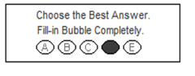

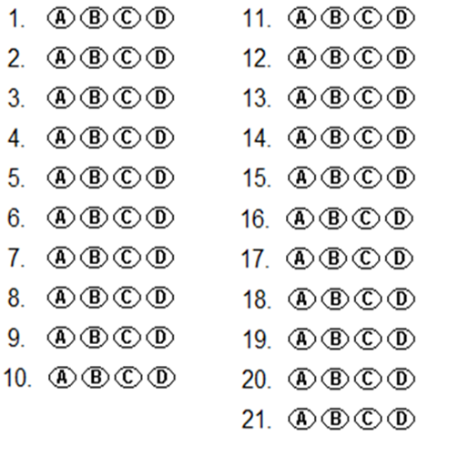

**1.** A growth of many microorganisms in one place is called a:

(a) Grouping.

(b) Colony.

(c) Culture.

(d) Organelle.

**2.** The word‘decontaminate’means:

(a) To help microorganisms grow.

(b) To classify microorganisms

(c) To make an area or object free of contamination.

(d) To stop microorganisms spreading from one place to another.

**3.** Select the incorrect statement regarding the term ‘microbiology’.

(a) It is the study of living things so small that they can only be seen with the naked eye.

(b) It is the study of living things so small that they can only be seen with a microscope.

(c) It is the study of living things so small that they can only be seen with a telescope.

(d) It is the study of non-living things so small that they can only be seen with a microscope.

**4.** In most light microscopes the lenses on the revolving nosepiece that can be changed to alter the magnification are called the:

(a) Eyepiece.

(b) Ocular lenses.

(c) Objective lenses.

(d) Hand lenses.

**5.** The nucleus, cell membrane and flagella are all examples of:

(a) Limbs

(b) Organs.

(c) Microorganisms

(d) Organelles.

**6.** An autoclave works by killing microorganisms using:

(a) steam at high pressure.

(b) disinfectant chemicals.

(c) boiling methanol.

(d) radiation.

**7.** Pasteurisation works by killing microorganisms using:

(a) methanol.

(b) disinfectant chemicals.

(c) heat to warm food to a specific temperature for an specific length of time then cooling quickly.

(d) radiation.

**8.** Gram positive bacteria and gram negative bacterial can be separated due to:

(a) their shape

(b) the shape of the colonies they form.

(c) the way their cell walls stain.

(d) how quickly they infect their host.

**9.** Select the correct statement.

(a) Heterotrophic bacteria are all pathogenic to humans.

(b) Autotrophic bacteria are all pathogenic to humans.

(c) Heterotrophic bacteria do make their own food.

(d) Autotrophic bacteria do make their own food.

**10.** Some bacteria are useful and some are dangerous and cause infection. The ones causing infection are called:

(a) aerobic.

(b) anaerobic.

(c) endemic.

(d) pathogenic.

**11.** Bacteria can be classified according to:

(a) shape.

(b) number of nuclei.

(c) who discovered them.

(d) the year that they were discovered.

**12.** Agar gel on a petri dish:

(a) kills off microorganisms and decontaminates the petri dish.

(b) gives microorganisms food and nutrients needed for their growth.

(c) helps stop the spread of microorganisms out of the petri dish.

(d) makes the microorganisms easier to see at a cellular level.

*Read the following Data and use it to answer questions 13 to 18 inclusive.*

**Ebola Virus Disease**

### Key facts (World Health Organisation)

* Ebola virus disease (EVD) is a severe, often fatal illness in humans.
* EVD outbreaks have a case fatality rate of up to 90%.
* EVD outbreaks occur primarily in remote villages in Central and West Africa, near tropical rainforests.
* The virus is transmitted to people from wild animals and spreads in the human population through human-to-human transmission.
* Fruit bats are considered to be the natural host of the Ebola virus.
* Ill patients require intensive supportive care. No licensed specific treatment or vaccine is available for use in people or animals.

Ebola first appeared in 1976 in 2 simultaneous outbreaks, in Nzara, Sudan, and in Yambuku, Democratic Republic of Congo. The latter was in a village situated near the Ebola River, from which the disease takes its name.

### Transmission

Ebola is introduced into the human population through close contact with the blood, secretions, organs or other bodily fluids of infected animals. In Africa, infection has been documented through the handling of infected chimpanzees, gorillas, fruit bats, monkeys, forest antelope and porcupines found ill or dead or in the rainforest.

Ebola then spreads in the community through human-to-human transmission, with infection resulting from direct contact (through broken skin or mucous membranes) with the blood, secretions, organs or other bodily fluids of infected people, and indirect contact with environments contaminated with such fluids. Burial ceremonies in which mourners have direct contact with the body of the deceased person can also play a role in the transmission of Ebola. Men who have recovered from the disease can still transmit the virus through their semen for up to 7 weeks after recovery from illness.

**13.** If you contract Ebola your are:

(a) likely to survive

(b) likely to die

(c) likely not to know you have it

(d) likely to be a fruit bat.

**14.** The Ebola virus:

(a) can only survive in humans.

(b) can infect humans and survive in fruit bats.

(c) is air borne.

(d) is water borne.

**15.** If a nurse or doctor was working with someone who was suffering from Ebola Virus Disease:

(a) they would be safe if they had been vaccinated against the virus.

(b) they would be protected by wearing a Hazmat suit.

(c) they can take antibiotics to fight the disease if they become infected.

(d) they would be safe if they had a hot shower after working with the sick person.

**16.** Ebola Virus Disease is an example of a/an:

(a) endemic.

(b) pandemic.

(c) bacterial infection.

(d) air borne infection.

**17.** If a man survives an infection of the Ebola Virus:

(a) he is no longer able to spread the disease to others.

(b) he is still able to spread the disease.

(c) he must have been vaccinated before he contracted the virus.

(d) he must not breathe on other people for the next 6 months.

**18.** People suffering from Ebola are kept away from other members of the Community.

(a) This is an example of transmission.

(b) This is an example of vaccination.

(c) This is an example of contamination.

(d) This is an example of quarantine.

**19.** A scientist conducts an experiment to test the theory that a vitamin could extend a person’s life-expectancy.

(a) The vitamins would be the independent variable.

(b) The life-expectancy would be the independent variable.

(c) The vitamins would be a controlled variable.

(d) The life-expectancy would be the controlled variable.

**20.** If you want to measure how much water flow increases when you open a tap, it is important to make sure that the water pressure going to the tap is held constant. In this case the water pressure is a/an:

(a) independent variable.

(b) dependent variable.

[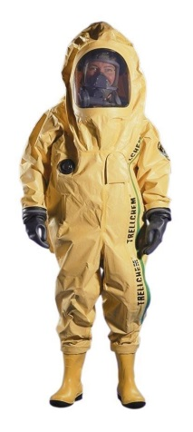](http://www.google.com.au/url?sa=i&rct=j&q=hazmat+suit&source=images&cd=&cad=rja&uact=8&docid=v5Rwv_Ib6V3VbM&tbnid=NlwqsgNs4yf9pM:&ved=0CAUQjRw&url=http://rapgenius.com/1196297/Danger-doom-mince-meat/Hazmat-suit&ei=K-DMU8GwCMO78gW9q4Ao&psig=AFQjCNG9szoYb_rQEjqa_b6RzbgpmZiS3Q&ust=1406022036879903)(c) controlled variable.

(d) control group.

**21.** The man in this picture is wearing a:

(a) bacterial cell outer coat.

(b) Hazmat suit.

(c) bacteria suit.

(d) virus suit.

**SECTION B: SHORT ANSWER (32marks)**

**1.** Work out the total magnification for the two microscope settings below. (2 marks)

Ocular magnification is 10x and objective magnification is 4x = _________________

Ocular magnification is 10x and objective magnification is 40x = _________________

**2.** A special unit of measurement is used when studying microbiology. State the name of the unit of measurement and its symbol. (1 mark)

______________________________________________________________________________________

**3.**  Label the microscope below. (4 marks)

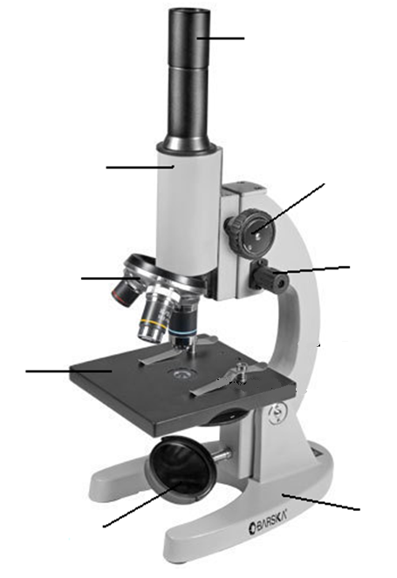

**4.** Many Countries have National High Security Quarantine Laboratories. (2 marks)

**a)** Explain why a country like Australia, that does not normally have outbreaks of diseases like Malaria and Ebola, would need to have a National High Security Quarantine Laboratory.

______________________________________________________________________________________

______________________________________________________________________________________

______________________________________________________________________________________

______________________________________________________________________________________

______________________________________________________________________________________

**b)** National High Security Quarantine Laboratories often have police or even army security. Explain what the purpose for this would be. (2 marks)

______________________________________________________________________________________

______________________________________________________________________________________

______________________________________________________________________________________

______________________________________________________________________________________

**5.** Explain the difference between aerobic bacteria and anaerobic bacteria. (2 marks)

______________________________________________________________________________________

______________________________________________________________________________________

______________________________________________________________________________________

______________________________________________________________________________________

**6.** State the shapes and names of three different bacterium below. (3 marks)

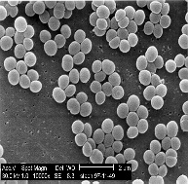

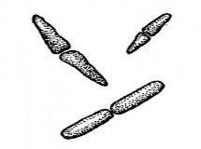________________________ _______________________

________________________ _______________________

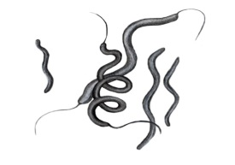

_______________________

_______________________

**7.** Explain the difference between a pandemic and an epidemic. (2 marks)

______________________________________________________________________________________

______________________________________________________________________________________

______________________________________________________________________________________

______________________________________________________________________________________

______________________________________________________________________________________

______________________________________________________________________________________

**8.** Explain how the diseases in biohazard level three are different to the diseases in biohazard level four.

(2 marks)

______________________________________________________________________________________

______________________________________________________________________________________

______________________________________________________________________________________

______________________________________________________________________________________

[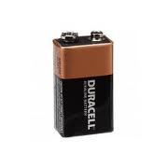](http://www.google.com.au/url?sa=i&rct=j&q=D+battery&source=images&cd=&cad=rja&uact=8&docid=E-b7fh3HDvX6qM&tbnid=kfyDIfTVZWmCYM:&ved=0CAUQjRw&url=http://www.b2bsupply.co/duracell-alkaline-coppertop-d-size-bulk-battery-2017-p-2240.html&ei=nZfRU7DDH5GKuATc7oGQBw&psig=AFQjCNFlQbRFB9LdOqbc4c1X7s5wdEDR4g&ust=1406331157480380)

**9.** Two different brands of 6 volt D batteries were compared to see which battery would last the longest**.** The two brands were Brand **X** and Brand **Y**. One Brand **X** 6 volt D battery was placed in a small hand torch. The torch was left on until the battery ran flat and the globe stopped glowing. The time this took was recorded. This was done with 99 other batteries of brand **X**. The results were recorded. The experiment was then repeated for 100 brand **Y** batteries.

**a)** State a possible hypothesis for this experiment. (2 marks)

______________________________________________________________________________________

______________________________________________________________________________________

______________________________________________________________________________________

______________________________________________________________________________________

**b)** Explain why 100 of each battery tested instead of only a few. (1 mark)

______________________________________________________________________________________

______________________________________________________________________________________

______________________________________________________________________________________

**c)** State the independent variable for this experiment. (1 mark)

______________________________________________________________________________________

**d)** State the dependent variable for this experiment. (1 mark)

______________________________________________________________________________________

**e)** State two controlled variables for the experiment. (2 marks)

______________________________________________________________________________________

______________________________________________________________________________________

The table shows the final table of results for this experiment.

|  |  |
| --- | --- |
| Brand of Battery | How long the torch stayed  glowing for (minutes) |
| **X** | 120 |
| **Y** | 360 |

**f)** Is this data quantitative or qualitative? Give a reason for your answer. (2 marks)

______________________________________________________________________________________

______________________________________________________________________________________

**g)** Draw a graph using the information from the table above. (5 marks)

[](http://www.google.com.au/url?sa=i&rct=j&q=graph+paper&source=images&cd=&cad=rja&uact=8&docid=bnDyK-WDEHhooM&tbnid=OH_xw5ZTcFEuvM:&ved=0CAUQjRw&url=http://virtualmathtutor.blogspot.com/2010/11/how-to-draw-circle-without-compass.html&ei=RKw4U5fxF8fClQWCrIGoCQ&psig=AFQjCNHahbsWAgdANQM5RZCXw4z48cLLBw&ust=1396309252654415)

**END OF TEST**